ASSIGNMENT - 7
- Write an exception handling java program to read two numbers n1, n2 and calculate and print the result of n1/n2. If n2 is Zero (0) then it will be handled by exception handler and again ask the value of n2. In the exception handler the program should display appropriate message to the user.
Code:
import java.util.Scanner;
public class Divison {
public static void main(String[] args) {
Scanner sc = new Scanner(System.in);
int n1, n2;
System.out.print("Enter first number (n1): ");
n1 = sc.nextInt();
while (true) {
try {
System.out.print("Enter second number (n2): ");
n2 = sc.nextInt();
int res = n1 / n2;
System.out.println("The Result = " + res);
break;
} catch (ArithmeticException e) {
System.out.println("Error: Division by zero not allowed. Please enter n2 again.");
}
}
sc.close();
}
}
Output:
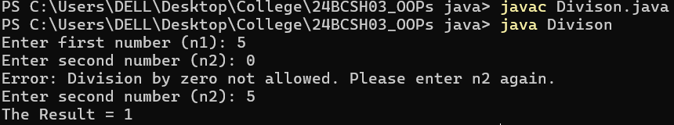

- Write a java program to read two numbers x and y and calculate x/(x−y). The program should check the value of x−y. Before dividing with x, it should throw an exception if x−y is zero. In the exception handler the program should display appropriate message to the user.
Code:
import java.util.Scanner;
public class SubDiv {
public static void main(String[] args) {
Scanner sc = new Scanner(System.in);
System.out.print("Enter x: ");
double x = sc.nextDouble();
System.out.print("Enter y: ");
double y = sc.nextDouble();
try {
if (x - y == 0) {
throw new ArithmeticException("Denominator (x - y) cannot be zero.");
}
double result = x / (x - y);
System.out.println("Result = " + result);
} catch (ArithmeticException e) {
System.out.println("Error: " + e.getMessage());
}
sc.close();
}
}
Output:
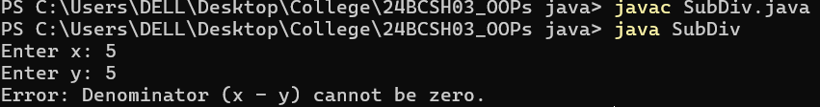
- Write an exception handling java program to print the index position of an existing integer array. The index value will be entered by user. It will be handled by exception handler if index position is greaterthen the size of array. In the exception handler the program should display appropriate message to the user.
Code:
import java.util.Scanner;
public class ArrayIndex {
public static void main(String[] args) {
Scanner sc = new Scanner(System.in);
int[] arr = {1, 22, 333, 4444, 55555};

try {
System.out.print("Enter index to access the Array Elements (0-4): ");
int index = sc.nextInt();
System.out.println("Element at index " + index + " = " + arr[index]);
} catch (ArrayIndexOutOfBoundsException e) {
System.out.println("Error: Index is out of range! Please enter between 0 to 4.");
}

sc.close();
}
}
Output:
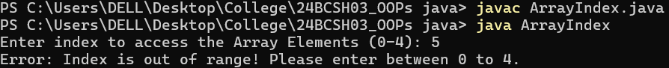

- Write a program to illustrate the use of multiple catch blocks associated with a single try block.
Code:
import java.util.*;
public class MulCatch {
public static void main(String args[]) {
try {
int a = 10, b = 0, c;
c = a / b;
int arr[] = { 1, 2, 3, 4 };
System.out.println(arr[7]);
}
catch (ArithmeticException e) {
System.out.println("Exception: ArithmeticException");
}
catch (ArrayIndexOutOfBoundsException e) {
System.out.println("Exception: Array Index OutOfBounds Exception.");
}
catch (Exception e) {
System.out.println("General Exception.");
}
}
}

Output:
- Write a class called Account with the following properties and methods:
Properties: String name, int acc_no, double balance
Methods: void deposit (double amt), void withdraw (double amt)
Assume that an account needs to have a minimum balance of 500. If an attempt is made to withdraw, which results in balance going below 500, throw a user defined exception called MinimumBalanceException. Use throw and throws wherever necessary.
Code:
class MinimumBalanceException extends Exception
{
MinimumBalanceException(String msg)
{
super(msg);
}
}
class Account{
String name;
int accno;
double balance;
Account(String name, int accno, int balance)
{
this.name = name;
this.accno = accno;
this.balance = balance;
}
void deposit(double amt){
balance += amt;
System.out.println("Deposit: " + amt);
System.out.println("The Current Balance : " + balance);
}
void withdraw(double amt)throws MinimumBalanceException{
if(balance-amt < 500)
{
throw new MinimumBalanceException("Exception: The Minimum Required Balance is : Rs. 500");
}
balance-=amt;
System.out.println("You have Withdrwal : Rs. " + amt);
System.out.println("Your Current Balance is : Rs. " + balance);
}
}
class Driver{
public static void main(String args[])
{
Account acc = new Account("Ronit", 2024321, 50000);
acc.deposit(5000);
try
{
acc.withdraw(100000);
acc.withdraw(30000);
}
catch(MinimumBalanceException e)
{
System.out.println(e.getMessage());
}
}
}Output: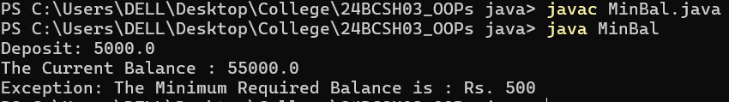
- Write a class called Account with the following properties and methods:
Properties: String name, int acc_no, double balance
Methods: void deposit (double amt)
void withdraw (double amt),
void transfer (Account acc1, Account acc2, double amt)
Assume that an account needs to have a minimum balance of 500. If an attempt is made to withdraw or transfer, which results in balance going below 500, throw a user defined exception called MinimumBalanceException. Use throw and throws wherever necessary.
Code:
class MinimumBalanceException extends Exception {
public MinimumBalanceException(String msg) {
super(msg);
}
}
class Account {
String name;
int acc_no;
double balance;
public Account(String name, int acc_no, double balance) {
this.name = name;
this.acc_no = acc_no;
this.balance = balance;
}
void deposit(double amt) {
balance += amt;
System.out.println(name + " deposited " + amt + ", Balance: " + balance);
}
void withdraw(double amt) throws MinimumBalanceException {
if (balance - amt < 500)
throw new MinimumBalanceException("Withdrawal Failed! Balance can’t be less than 500.");
balance -= amt;
System.out.println(name + " withdrew " + amt + ", Balance: " + balance);
}
void transfer(Account Acc1, Account Acc2, double amt) throws MinimumBalanceException {
if (Acc1.balance - amt < 500)
throw new MinimumBalanceException("Transfer Failed! Minimum Balance should be 500.");
Acc1.balance -= amt;
Acc2.balance += amt;
System.out.println("Transferred " + amt + " from " + Acc1.name + " to " + Acc2.name);
}
}
public class Transfer {
public static void main(String[] args) {
Account a1 = new Account("Ronit", 1001, 2000);
Account a2 = new Account("Kumar", 2002, 1500);
try {
a1.transfer(a1, a2, 600);
a1.transfer(a1, a2, 1000);
} catch (MinimumBalanceException e) {
System.out.println("Error: " + e.getMessage());
}
}
}
Output:
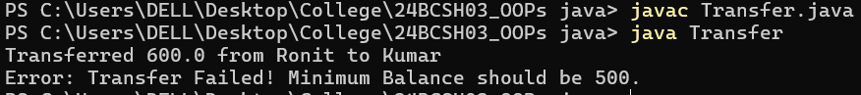
- Write a program that prompts the user to enter a length in feet and inches and outputs the equivalent length in centimetres. If the user enters a negative number or a non-digit number, throw and handle an appropriate exception and prompt the user to enter another set of numbers.
Code:
import java.util.*;
class Conversion {
public static void main(String[] args) {
Scanner sc = new Scanner(System.in);
while (true) {
try {
System.out.print("Enter feet: ");
double f = sc.nextDouble();
System.out.print("Enter inches: ");
double i = sc.nextDouble();
if (f < 0 || i < 0)
throw new IllegalArgumentException();
double cm = (f * 12 + i) * 2.54;
System.out.println("Equivalent length in centimeters: " + cm);
break;
} catch (InputMismatchException e) {
System.out.println("Invalid input. Enter numeric values.");
sc.nextLine();
} catch (IllegalArgumentException e) {
System.out.println("Negative values not allowed. Try again.");
}
}
}
}
Output:
